ACTIVITIES FOR COACHES TO USE

Eyes/Knees/Toes/Ball (Concentration/Competition)
Players have a ball each between their legs. Coach stands in front of the players calling out body parts and at the same time touching that body part with their hands and player copy. Very similar to “Simon Says”. When the coach says ball the players quickly grab their ball and lift it over their head as quickly as they can. They can be trying to be quicker than you. Important to have fun with this one.

Ball Pass – Over/Under, Inside/Outside (Concentration/Social)
Players pair up one ball between tow. The players stand back to back and pass the ball under (through their legs) and over their head or hand the ball to their partner passing it off to the right and twist to the other side to get the ball from the left side. If the players move a little apart one player twists left the other right and make a figure eight passing the ball off to each other. Have them switch the direction they are going.

Ouch (Dribbling)
Players have a ball each trying to hit the coach below the knees by passing their ball. If the coach gets hit by a ball he yells “Ouch”. The coach walks around the space changing direction trying not to get hit. This a good one to walk slowly and even stop in front of some players to let them hit you.

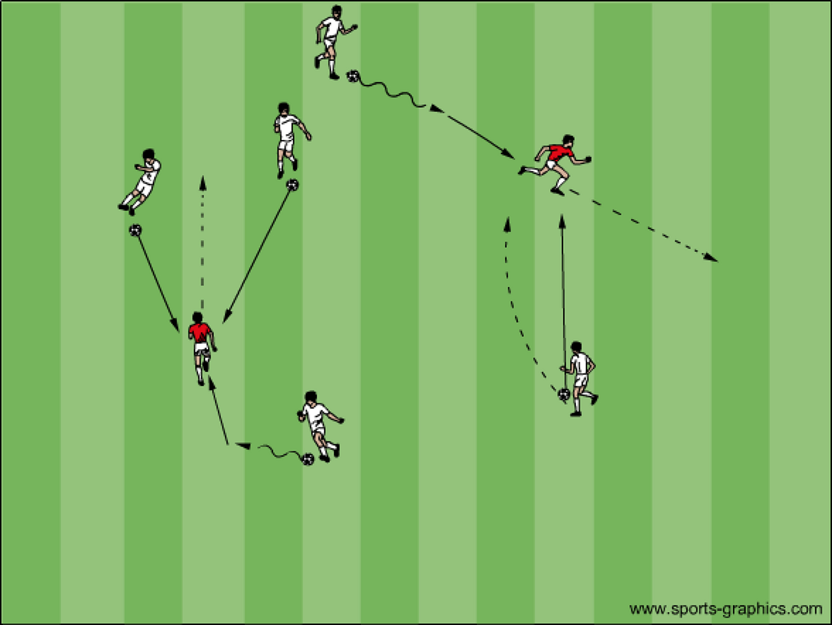

I can do this, can you? (Intro Activity) The coach shows the players something he can do then asks them to copy. This can be challenges with or without the ball. Start with very easy activities such as running, skipping, hoping, walking backwards, skipping backwards then move to challenges with the ball such as bouncing and catching, rolling, kicking, dribbling etc. The coach can then ask the players to show everyone something they can do then everyone tries to copy. This very basic introduction to each session gives the players confidence to leave their parents side and work with the rest of the group.

Toss and Clap
Players have a ball each holding it in their hands. “I Can do This Can You” show them you can toss the ball up and catch it. Progress to toss the ball up and clap once before catching. Progress to two claps, three claps and so on. I like doing this one as a lead in to thy juggling. For thy juggling the players holding onto their ball tap their ball with their thigh like they are marching in place. Progressing to bumping the ball out of their hands and catching it. Progressing to two thy bumps and so on. This is the intro to juggling.

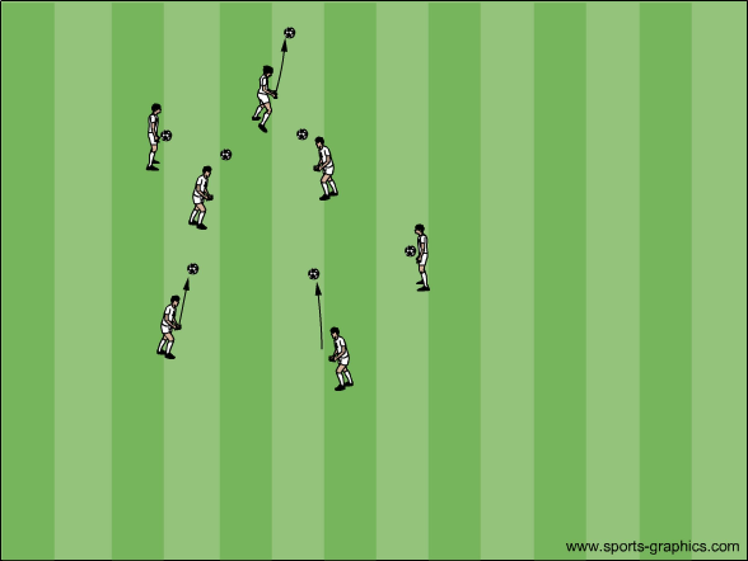

10 Steps Each player has a soccer ball within a 20x20 grid. The coach sings out a rhyme. The players react to each number
For the first week the coach should go over steps 1-5. The next week add on steps 6-10
1: Number One is On the Run (players run with the ball)
2: Number Two’s the Sole of the Shoe (players stop the ball with the bottom of the foot)
3: Number Three is On the Knee (players touch the ball from knee to knee)
4: Number Four is Head to the Floor (players place their forehead on the ball)
5: Number Five is Do a Dive (players dive down onto the ball)
6: Number Six is Do Some Tricks (Coach gives the players a very simple trick to try)
7: Number Seven is Ball to Heaven (Player throws ball in the air and tries to stop it before it stops bouncing)
8: Number Eight is Run to a Gate (Players leave their ball, run to a gate – 2 cones- then back to their ball)
9: Number Nine is Its All Mine (Players try to keep their ball away from the coach) 10 Number Ten is Head it Again (Players try to head into their own hands)

Ball Tag (Dribbling/Passing)
Each player with a ball uses their ball to tag another player’s ball without letting their ball get tagged. Objective of the game is to tag as many balls as you can without letting your own ball get tagged. Players get lots of touches on the ball using different surfaces of their foot. It is chase and retreat activity.

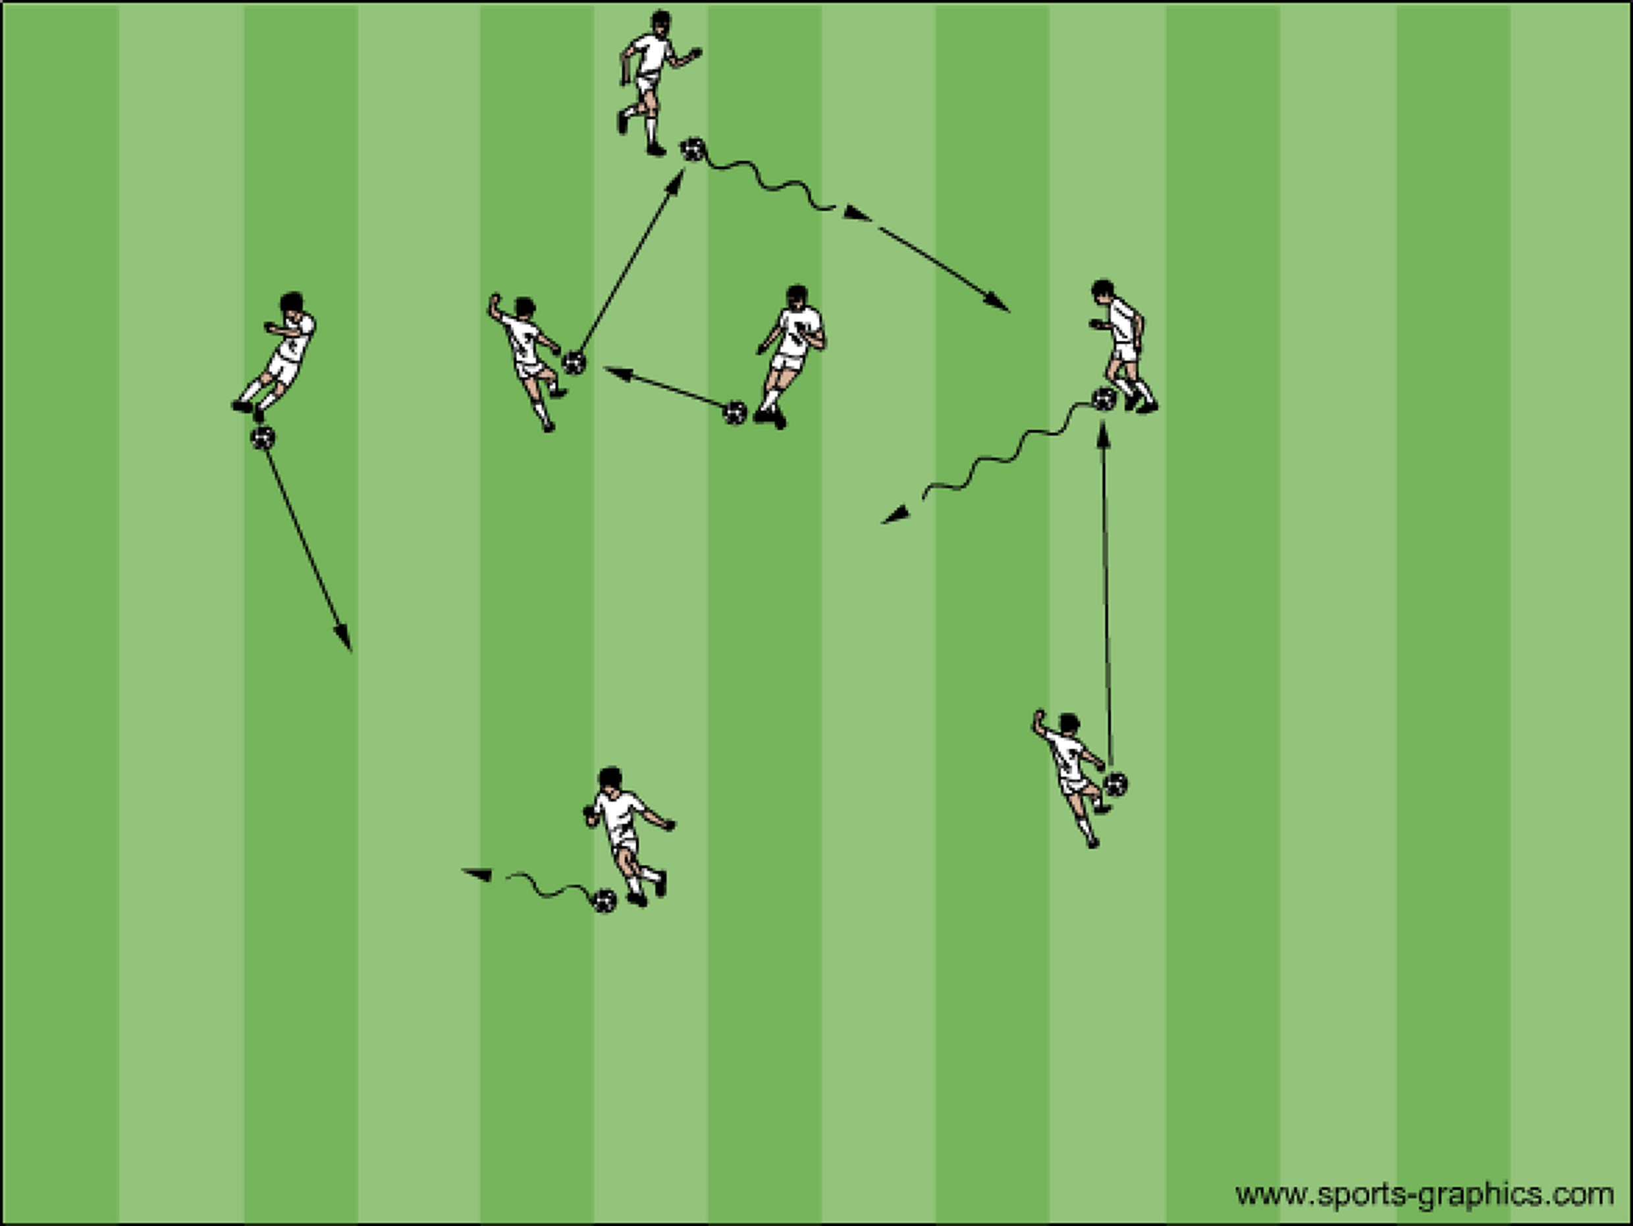

Everybody’s It (ABC’s/Dribbling)
First time playing this game do it without a ball. Players try to tag each other as many times as they can. The benefit of this activity is the movement of the players. Fast/slow, stopping/starting, changing direction. After 30 seconds ask the players how many people they tagged then play again challenging them to tag more people than they tagged last time. Progression: have them each get a ball holding it in one hand, then progress to the ball at their feet.

Tail Tag (ABC’s/Dribbling)
Each player has a pinnie and tucks it into their shorts making a tail. Players try to steal and hold onto as many tails as they can without losing their own. Keep playing even if you do not have a tail. 30 seconds pause the activity to see how many tails people have. To restart players give back tails to those who do not have one and play again. Without a ball and then with a ball.

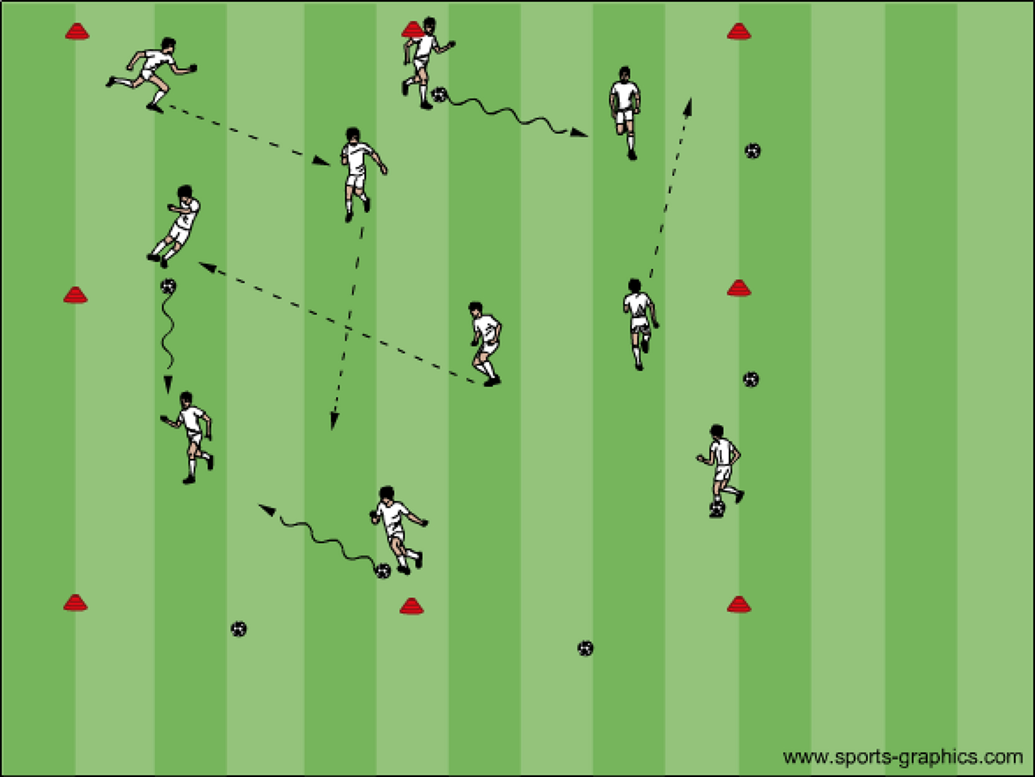

Hospital Tag (Dribbling)
This game has big space that everyone moves around in. There is a little space that is used as the hospital. The objective of the game is to send others to the hospital by tagging them. When tagged you need to use a free hand as a band-aid to cover up the area where you were tagged. If tagged a second time use your other hand to cover the other area you were tagged. You can release a hand your using as a band-aid to quickly tag someone. If tagged a third time you need to go to the hospital because you have run out of hands (band-aids). When in the hospital have the players do a skill. Three toe taps, three juggles, etc. Then they are healed and can go back into the game with two free hands.

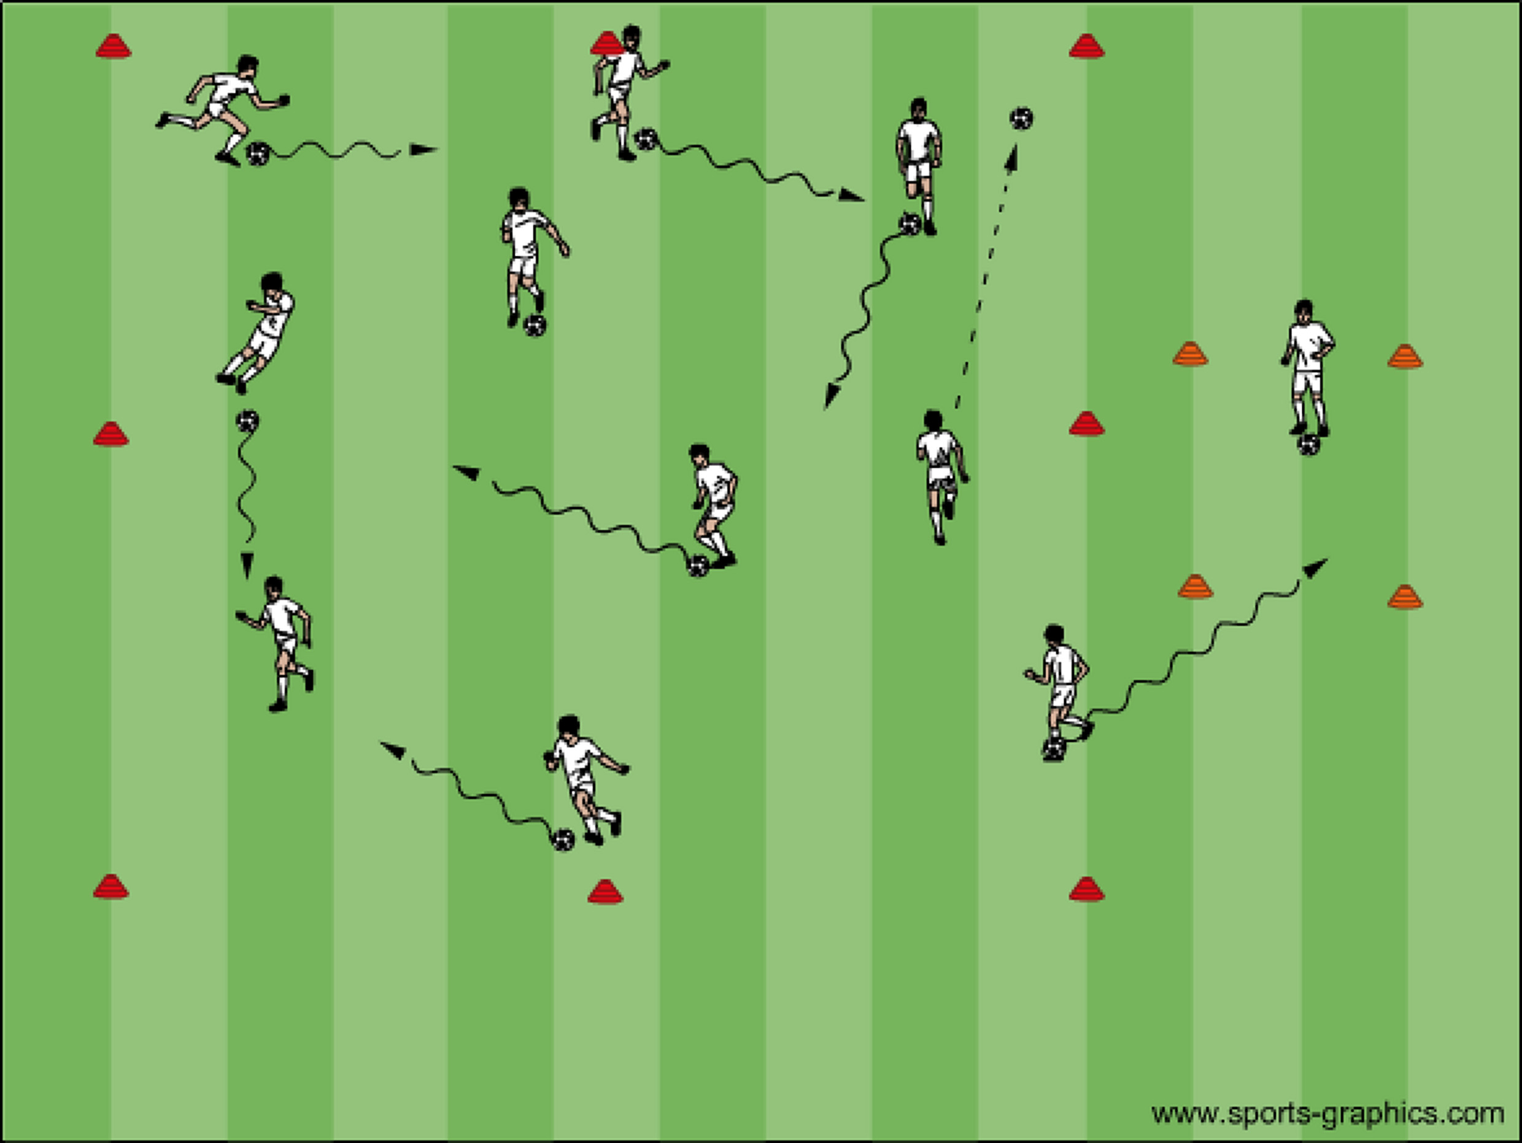

Math Dribble (Dribbling)
Players are dribbling their ball, when coach calls out a number the players need to quickly get into groups of that number.

Body Part Dribble (Dribbling)
Players are dribbling their ball, when coach calls out a body part the players stop their ball with that body part. For example: knees, toes, nose, ear, elbow, hand, head, back.

Spider’s and Fly’s (Dribbling)
Players line up on the end line (Fly’s) and need to get to the opposite side of the space without and then with a ball trying not to get tagged by the (Spider’s) who are on the field.
Spiders: “We are the spiders”
Fly’s: “We are the fly’s”
Spiders: “We are going to get you”
Fly’s: “Let me see you try”
Then the fly’s run across the field. If caught the fly’s turn into the spiders. Keep playing until all the fly’s are gone.

Gophers and Trees (Dribbling)
Players pair up. The players talk to each other deciding who is going to be a gopher and who is going to be a tree. Trees stand up with their legs more than shoulder width apart. The gophers run to crawl under as many trees as they can. Progress to having a ball and dribbling and pushing their ball underneath as many trees as they can.

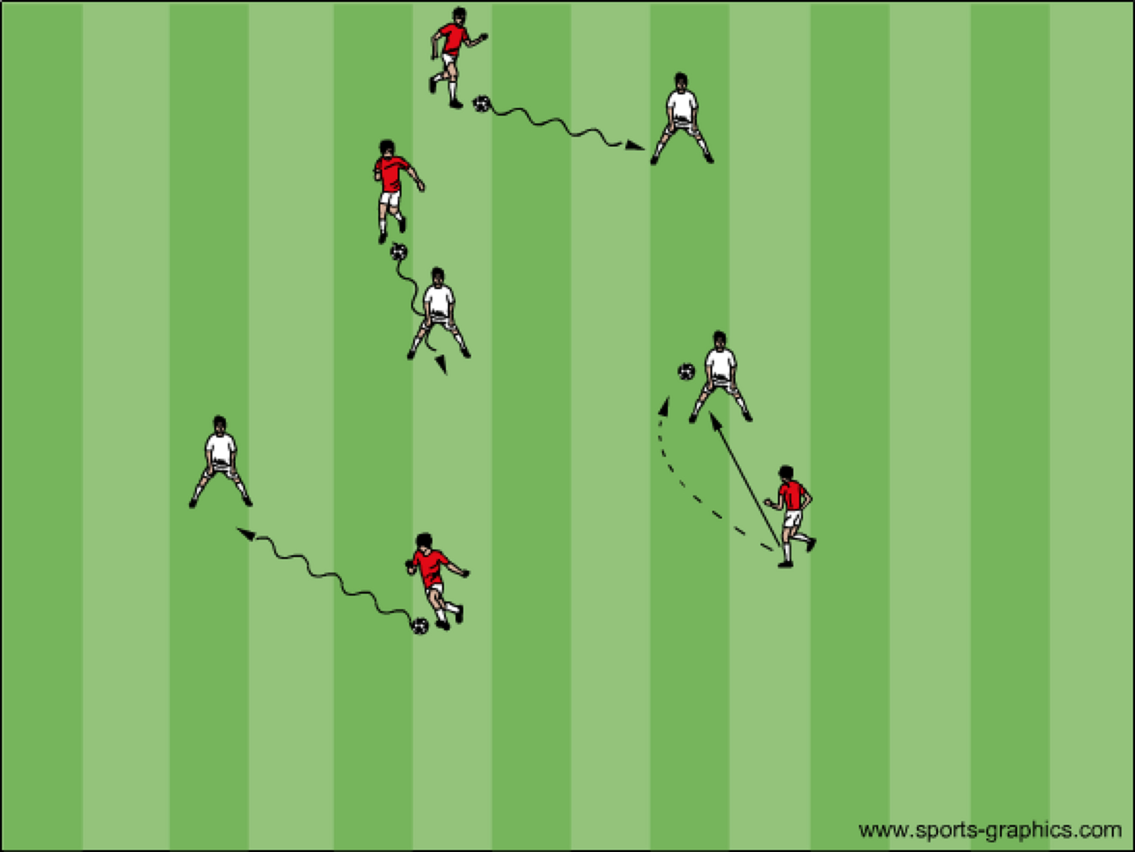

Saucers and Teacups (Dribbling)
Players are divided into two teams. Half are Teacups and half are saucers. Cones that are placed right side up are saucers and cones that are flipped over are teacups. Players run around turning cones over to get more of what their team is. Play for 37 seconds and have the player’s count how many teacups and saucers there are. Congratulate them on their effort and play again. This is a good one to jump in and turn cones over if it is getting lopsided.

Freeze Tag (Dribbling)
All players have a ball. One or two players without a ball wearing pinnies are the taggers. The objective of the game for the taggers is to “freeze” everyone and for everyone else to not let that happen. Players with a ball can unfreeze or defrost a player that is frozen by pushing their ball through the players legs. A player is frozen when tagged they pick up their ball and spread their legs more than shoulder width apart. They should call for “help”. Play for a minute and switch taggers. The players choose who the next taggers are by handing their pinnie to someone and that person giving them their ball.

Stuck in the Mud (Dribbling/Passing) Each player has a ball except for two MUD MONSTERS (coach to start with). The MUD MONSTERS run around and try to tag the other players. If a player gets tagged they must pick up the ball, put it above their head, and shout HELP ME!! To be freed another player must pass the ball through the frozen players legs. Rotate MUD MONSTERS around until everyone has had a shot.

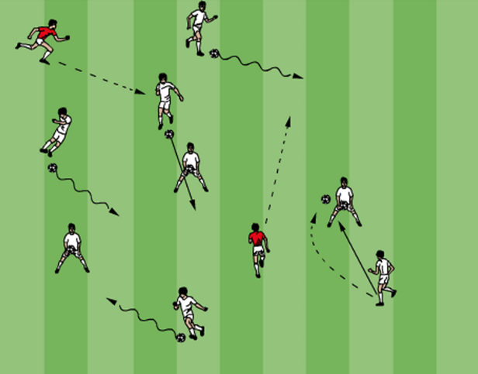

Cone Man/Girl (Dribbling/Turning) Each player has a ball except for 2 Cone Men/Cone Girls. The Cone Men/Girls have a cone each and they chase the other players and try to place the cone on their soccer ball. If a player is ‘Coned’ they stop, pick the ball up, kick and catch, then they are back in the game.

Alien Attack (Dribbling) Each player has a ball except for 2 Aliens (who have a cone on each ear) The Aliens chase the other players around the area (planet soccer) and try to kick away their soccer balls. If a player’s soccer ball is kicked away they must perform 3 juggles (dependent on age) then they can re-enter the game.

Gates (Dribbling/Passing) Set out a series of ‘gates’ (marked out by cones) throughout the area. Make the ‘gates’ different in size. Set challenges for the players. Such as: dribble through as many gates as possible, dribble through different colored gates, play the ball through the gate in the air etc. Progress to having two players (with one ball between then) moving around the area and passing through the gates. Progression: Add Gate Keepers, this is also a good one to get parents involved. The gates they are standing in are closed and the players need to find the open gates. There are two ways to manage this one. You as the coach and point to a gate to open or close the gate by the parents stepping out or in the gate or the parents can move randomly to different gates to close them just by standing in the gate.

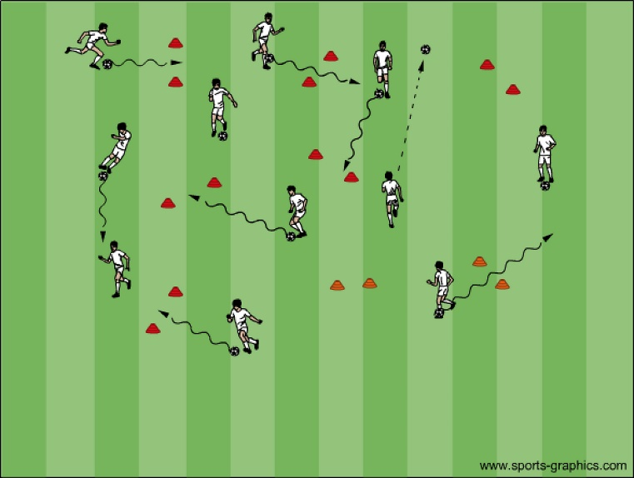

Moveable Gates (Dribbling/Passing)
This is a good one to get the parents involved is there are any sitting and watching. Two pinnies can be tied together and two parents each holding an end make a gate. The gates should spread out on the field. Players try to get the ball through as many gates as they can by passing the ball through and running around the other side to get their ball. Once they have done this a couple of times getting the ball through as many gates as they can. Progression: Have the gates move. This can be done individually, pairs, or groups of three or four.

Body Brakes (Dribbling)
Each player has a ball and dribbles within the 20x20 area. The coach calls out a part of the body. The players try to stop their ball with that part of the body.

Pac Man (Dribbling/Passing) Three “Ghosts” with soccer balls dribble around the area and try to pass the soccer ball to hit the Pac Men below the knees. Pac Men can move freely around the area to avoid being caught. If caught the Pac Men get their ball and become a ghost until all Pac Men are caught.

Bulldogs and Poodles (Dribbling/Passing)
Same as Pac Man but different name. The bulldogs have a ball and the poodles are without placing their ball on the boundary of the field ready to use if they need it. If a poodle gets hit by a ball they turn into a bulldog and need to go get a ball. The objective of the game is to stay a poodle or turn the poodles into bulldogs. The bulldog can only use their own ball. If a bulldogs tries several times you as the coach can jump in as a bulldog to help get a couple of poodles and then step out letting the game evolve. Game ends when there one or two poodles left. They are the bulldogs for the start of the next game.

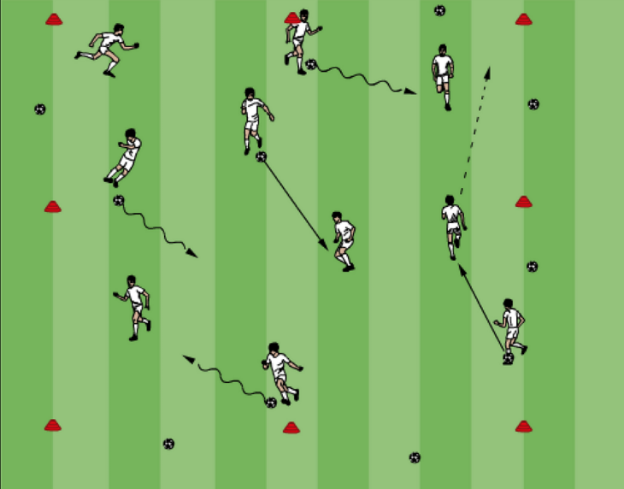

Capture the Flag (Dribbling/Passing)
If you have twelve players they are divided up into four teams of three. Each team goes to their respective corners of the field in a small three x three yard space made with cones. All of the balls are placed in the middle of the field. Game begins when you say go and ends when you say stop. Until the game ends any ball is free game. Objective of the game is to have as many balls in your corner as you can when the game ends. The trick is the players do not know when the game is going to end. Variations: Players can only dribble the ball back to their corner, players can only take three touches to pass the ball back. This is a good one to give the players a chance to talk to each other to come up with a strategy.
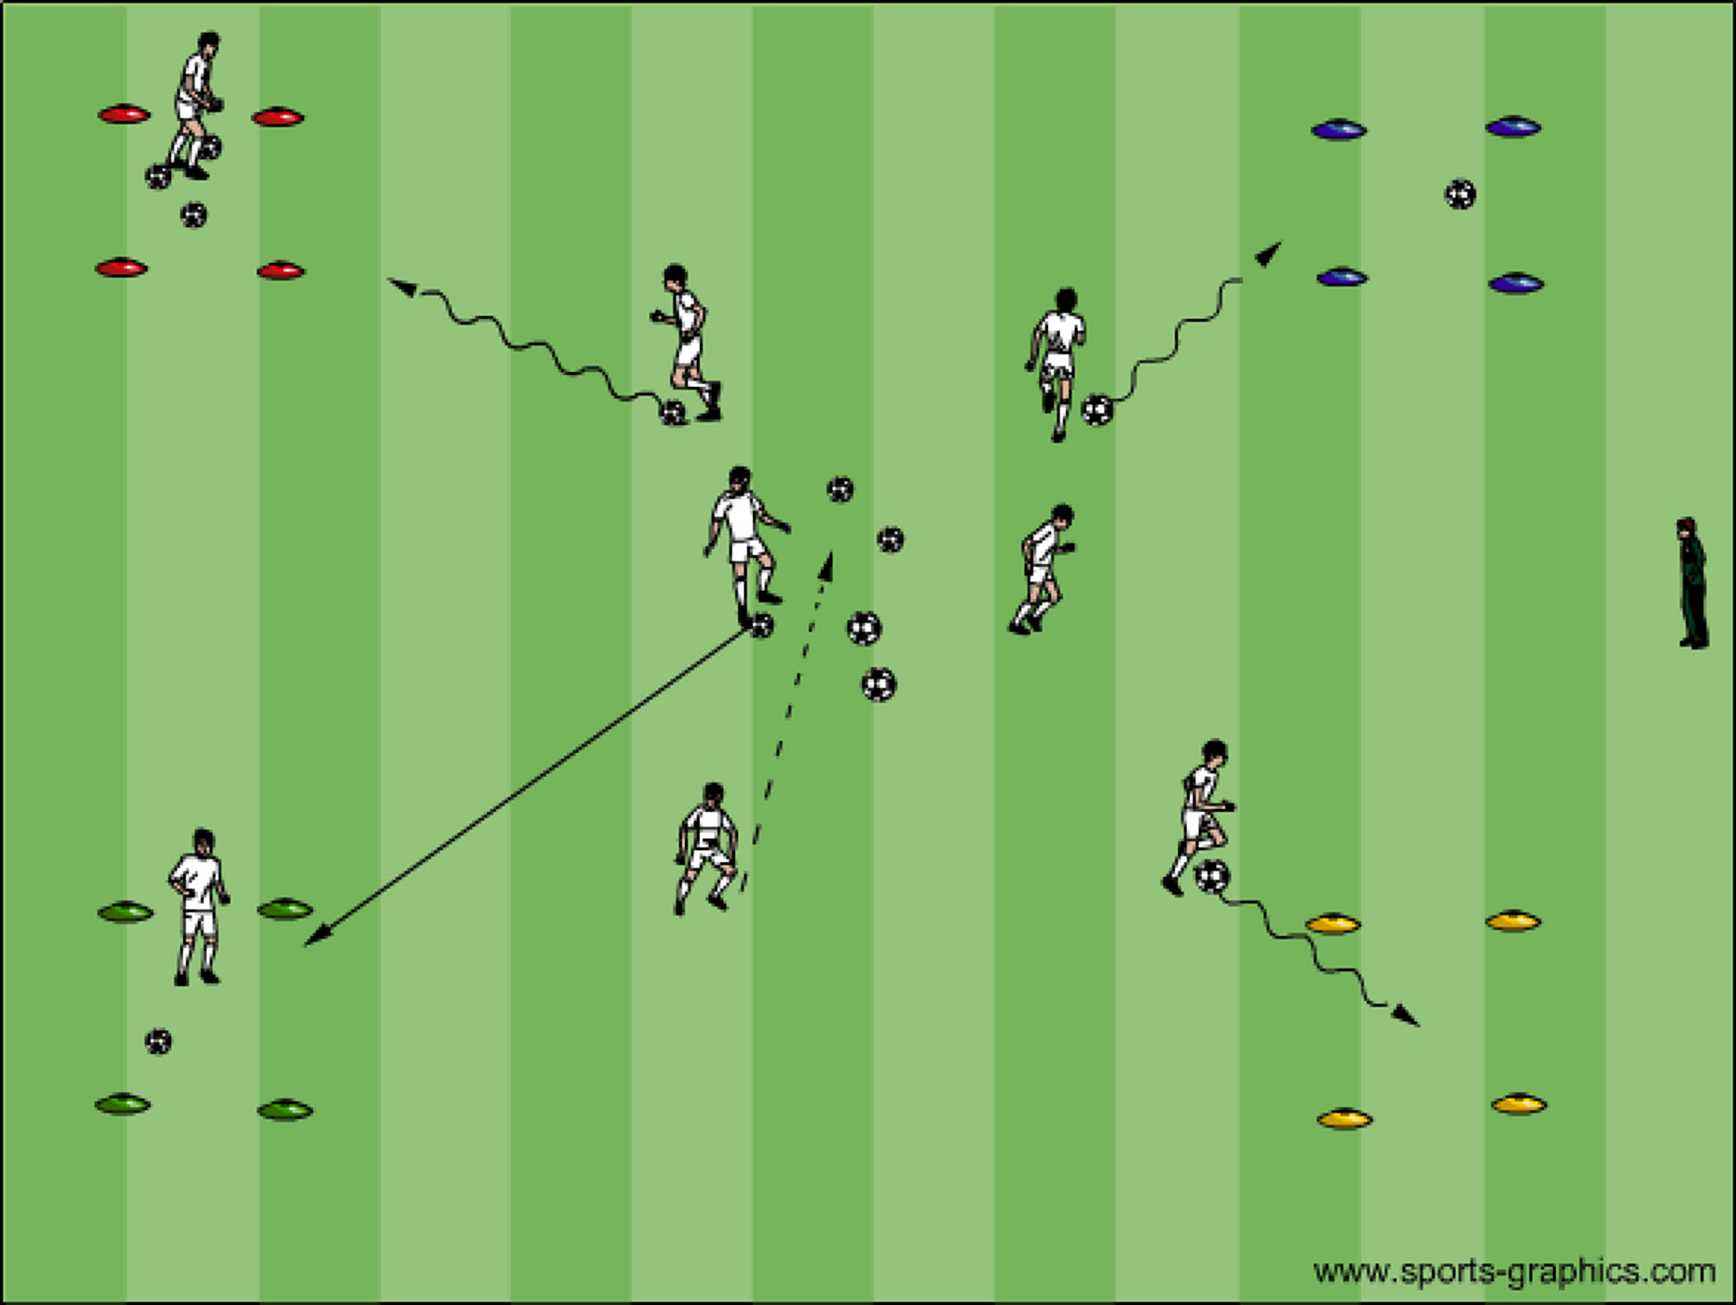

Elbow Tag (ABC’s)
Players pair up by linking elbows. Two players are chosen to not be linked. One is it and one is getting chased. Players that are linked spread out in the space and do not move.
The player getting chased can be safe when they link elbows with a pair. The player on the opposite ends needs to release and run to another pair without getting tagged. If tagged you become the tagger. The tagger is identified by holding a jersey, cone or ball. Variation: The linked players can lay like logs next to each other on the ground. Players then lay down and get up. Progression: Chaser can have a ball at their feet dribbling and tagging or using the ball or tag by passing and hitting the player not linked below the knees, similar to what was done in Pac Man.

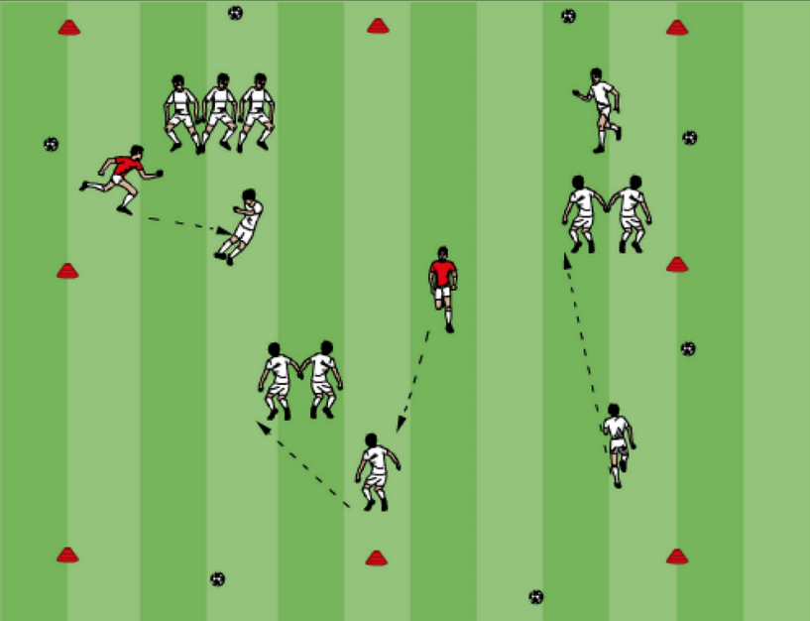

Soccer Marbles (Passing) Two players play against each other (ball each) on the whole field. Player one passes their ball anywhere in the field. Player two has to try to pass their ball to try and hit player ones ball. If he does he gets a point, if he doesn’t player one then tries to hit players two’s ball and so on.

DVD Movie World (Dribbling) Each Player has a ball. They move around the area (DVD world). The Coach is the DVD ‘Remote Control’ and gives the players instructions.
Play: Players dribble around the area Stop: Players stop the ball quickly Fast Forward: Players run as fast as possible with the ball under control Rewind: Players run backwards with the ball Pause: Players stop and perform taps on top of the ball Record: Players follow another player and copy their movements Eject: Players stop their ball, run to the outside of the area and shout the name of their favorite movie (Continued below)

Tractor Trailer (Dribbling)
Players have a partner. Both players have a ball. One player leads (tractor) the other player follows (trailer). When the Coach shouts ‘Tractor Trailer’ the front player (tractor) tries to run away from the trailer. When the Coach shouts ‘Stop’, both players must stop quickly. If the Trailer can take 5 big steps and touch the Tractor they get a point. If not the Tractor gets the point.

Pirates of the Caribbean (Hand-Eye coordination)
This is a short fun introduction to Goalkeeping. Each player (shipmates) has a ball. The Coach is the Captain of the Ship. The Captain moves around the area (Deck) and gives his shipmates commands to follow.

Clean the Deck: Players run around the area holding the ball in front of them.
Pirates: Players ‘Scream’ and bring the ball into the body to keep away from the pirates.
Rock the Boat: Players bounce the ball and catch
Birds: Players throw the ball in the air and catch
Sharks: Players scream and dive down onto their ball
Water: Players roll the ball in front then ‘scoop’ it up
Round the World: Players rotate the ball around their body.

Doctor Doctor (Dribbling)
You will need a marked out area larger area with two smaller areas for the 'doctors houses'. The players need to be split into 2 teams and everyone except two players will need a ball each.

Two teams battle it out to win this game of doctor doctor. Each team will need a doctor who will start in their smaller area (doctor house) without a ball. All the other players start somewhere inside the larger area with a ball each at their feet.

The object of the game is to try and kick the other teams balls outside of the area and retain yours. If a players ball is kicked out of the area they must leave it and go to ground shouting 'doctor, doctor help!' This player can only retrieve their ball and stand up and carry on once their teams doctor has tagged them.

To win the game, a team must pass/kick their ball at the other teams doctor once they come out to tag their team mates who have had their ball kicked out. This game may sound complicated but it really isn't. The doctors cannot be shot at if they are in their doctor houses. This will encourage the players with balls to attempt to tackle the other players and kick their balls out of the area.

The players who are kicking the ball at the doctor must aim for a pass to hit below the knee. Games like this one need explaining and demonstrating step-by-step until the players understand what they must do. It is also okay to stop the game half way through to show a coaching point.

Progression
It is important to change the doctor after every game to allow each player to have a go with the ball at their feet. Give a team a point for skillful or clever play such as doing a turn or a trick or changing direction well with the ball at their feet.

Coaching Points:
Demonstrate clearly the ABC of passing and get one of the players to show everyone else how the doctor could be hit. Demonstrate clearly how to shield the ball using your body!
Make sure the kids use little touches and demonstrate what happens if you kick the ball too far in a game.
Make sure the kids use the inside and outside of their feet while dribbling – Big toe, Little toe.
Demonstrate every turn that you use and show the players how this could work in a game situation.
Make sure the kids change direction frequently and reminders to keep their heads up to see where they are going and ensure they do not bump into anyone.

Boss of the Balls (Dribbling/Passing/Shooting)
This is set up in such a way that gives you the coach control of who is in and how long they play. All of the balls start with you. This can also be called “New Ball”. This is when you introduce a new ball to the game when it goes out of bounds or into the goal to keep the activity continuous with very little to no down time.

3v3 Game Setup

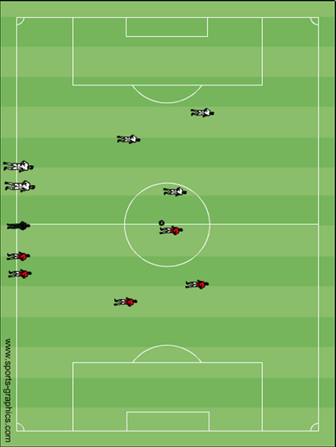
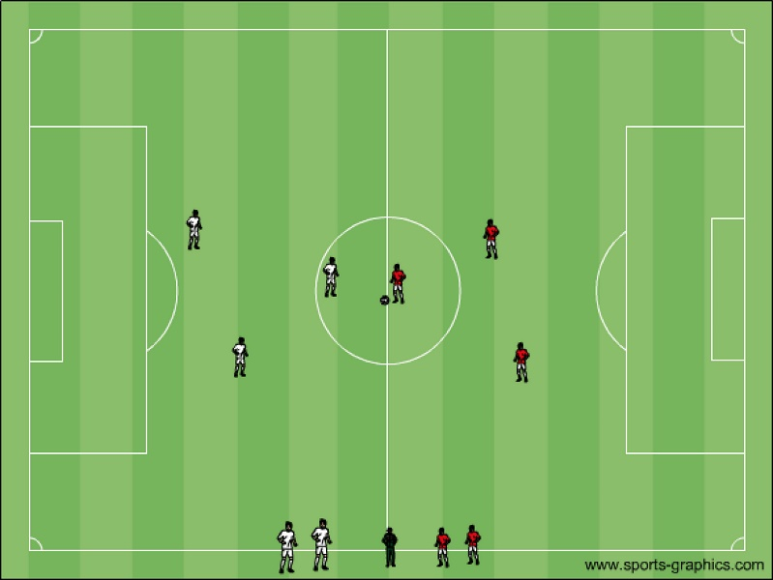

5v5 Game Setup
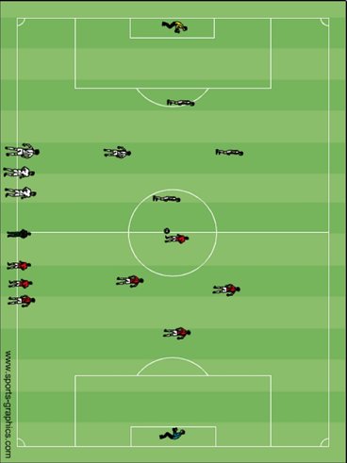

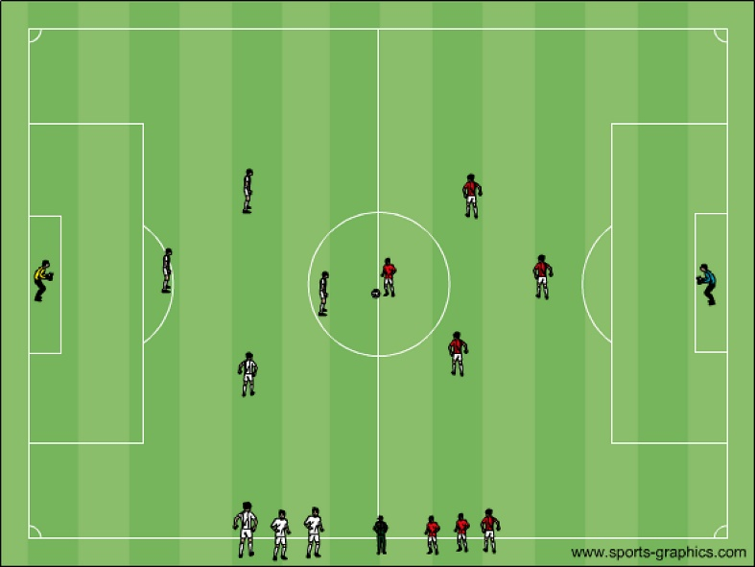

Get Outta Here (Game)
This is my favorite. You have two teams and one team is in a line shoulder to shoulder on your right and the other on your left. You are in between them with all f\of the balls very much like boss of the balls. The first person for each team is closest to you and the balls. When you role a ball out onto the field the first person for each team runs out playing 1v1 to try and score. They keep playing until someone score, the ball goes out of bounds or you say “Get Outta Here”. When the players come off they go to the end of the line furthest from you to get ready to go again. This helps you control the amount of time the players are waiting to play. Progression: First person in line brings the next person in line with them and play 2v2, which can progress to 3v3. An important component of this is the visual start you rolling the ball with NO verbal command. There can be a verbal command to end the game if need to control the time. Each 1v1 or 2v2 should not last longer than 20 seconds.

